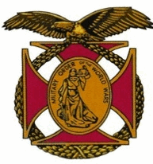

Meeting of the General J. P. Holland Chapter of the MOWW
September 2nd, 2017

The Chapter gathered at the Bernardo Heights Country Club at 1100

The meeting was called to order at 1132 by Chapter Commander, Nick Herbka.

Nick introduced all companions and guests, including the Guest Speaker and her Husband.

Acting Chaplain, Carl Swepston gave the invocation followed by the Pledge of allegiance led by Companion Don Hershberger. David Piontek read the Preamble.

A Outstanding Service Medal and Certificate was presented to Diane Herbka for her service to the Chapter as Treasurer for the past three years.

Tom and Kay Lettington conducted an award ceremony to award a Quilt of Valor to Carl Swepston, marking his outstanding service as a member of the UDT/SEAL service during the Vietnam Era.

Lunch was served at 1215

During lunch the guest speaker, Colette Alford told her story about growing up in France in Normandy before, during and after World War II.

Following his presentation, Nick Herbka presented a Certificate of Appreciation to our Guest Speaker. A Chapter Challenge coin was presented to our Guest Speaker by Carl Swespton

Acting Chaplain Carl Swepston gave the benediction, and the meeting was adjourned at 1345.

